**leaf guard: Bacterial Leaf Blight and brown spot rice leaf prediction using CNN based architecture**

***Abstract***— *Predicting the rice leaf disease efficiently is essential for preserving crop health and ensuring a high yield. A suggested approach leverages transfer learning using a pre-trained ResNet-18 architecture of CNN (Computational neural Network)model that has been trained using ImageNet and its fine-tuned layers help for classifying common rice leaf illness(Bacterial Leaf Blight, Brown spot and leaf smut).Deep learning is an important sector in artificial intelligence nowadays, deep learning are primarily used in image processing. CNN architecture can handle the complex characteristics of rice leaf images pre-processed into an industry-standard format and strengthened for resilience. With evaluation matrix precision(0.9653), recall(0.9583), F1-score(0.9591), specificity(1.00), epoch(15/15) and gross entropy loss(0.0066).The model achieves overall validation accuracy of 95.83%.The result demonstrates the efficiency of a CNN-based approach for automatic rice leaf disease prediction, providing scalable and efficient solutions for agricultural disease management. Recent advancements in deep learning, particularly convolutional Neural network (CNN), have enabled significant improvements in automated image-based disease detection. The CNN architecture contributes to agriculture by enabling early detection and intervention of the crop disease, ultimately minimising crop loss and food security.*

***Keywords****: Rice leaf disease prediction, Convolutional Neural Networks (CNN),Transfer learning,ResNet-18 architecture,Bacterial Leaf Blight, Brown spot, Leaf smut, Precision agriculture ,Deep learning in agriculture, Validation accuracy.*

**INTRODUCTION**

Rice or agriculture plays a vital role in the global economy sustainability and global food security ,rice is one of the most crucial worldwide. However the growth and yield of rice crops are severely affected by various diseases, including Bacterial Leaf, Blightspot, And Leaf Smut. Early detection and accurate identification of these diseases are essential to irrigate crop loss and ensure high production. Traditional diseases identification methods rely heavily on manual inspection, which can be labour-intensive, time-consuming, and prone to human error.

Recent advancements in deep learning, particularly convolutional Neural network (CNN), have enabled significant improvements in automated image-based disease detection. CNN architectures are highly effective in analysing visual data, allowing them to handle complex patterns and features in image. These models are increasingly being applied to precision agriculture, offering scalable and efficient solutions for disease management.

Proposed deep learning-based approach for predicting rice leaf disease using transfer using transfer learning on a pre-trained ResNet-18 model. Transfer learning allows us to leverage knowledge from large-scale datasets, such as ImageNet, to improve the performance of our model on rice leaf disease classification. By fine-tuning the ResNet-18 architecture , we are able to classify rice leaf diseases with high accuracy and minimal computational resources.

The model is evaluated using key performance metrics, including precision, recall, F1-sore, specificity, and validation accuracy, achieving an overall accuracy of 95.83%. The results demonstrate the effectiveness of CVV-based models for the automated detection of rice leaf disease, offering a practical solution for real-time agriculture disease management. Early detection of diseases using this approach can significantly reduce crop loss and contribute to food security.

**LITERATURE REVIEW**

The application of deep learning techniques in agriculture disease detection has gained significant traction in recent years. Convolutional Neural Network (CNNs) have demonstrated remarkable performance in image classification tasks due to their ability to automatically learn features from raw image data. This section reviews key research studies and methodologies that have laid the foundation for our proposed rice leaf disease prediction model.

In the work of Brahimi et al. [1], the authors utilized a deep CNN for automatic identification of plant diseases using leaf automatic identification of plant diseases using leaf images.

Their model achieved high accuracy in classifying several types of plant diseases, including those affecting tomatoes and wheats. Similarly, sladojevic et al. [2] applied a CNN-based approach to classify 13 different types of plant diseases from images, achieving impressive accuracy levels. These studies highlighted the efficacy of CNNs in handling the complex visual features of plant leaves and motivated the extension of these techniques to rice crops. Focusing specifically on rice leaf diseases, Mwebaze and Owomugisha [3] presented a machine learning approach for rice diseases diagnosis using image data. They experimented with several traditional machine learning models, including k-nearest neighbors and random forest, achieving moderate classification accuracy. However, their model’s performance was constrained by its reliance on manually extracted features, a limitation that can be addressed using deep learning.

A more advanced approach was proposed by lu et al. [4], where a deep CNN model was used to identify three rice leaf diseases: Bacterial Leaf Blight, Brown Spot, and Leaf Smut. The model achieved a classification accuracy of 93.33% on a

Dataset of 500 images. However, the relative techniques such as transfer learning limited the model’s generalizability. This paper builds upon Lu et al. 's work by incorporating transfer learning, leveraging a pre-trained ResNet-18 model to enhance accuracy and reduce the need for large datasets.

In the domain of transfer learning, he et al. [5] introduced RestNet (Residual Networks), a powerful CNN architecture that has been widely adopted for various image classification tasks. ResNet’s deep architecture, consisting of residual blocks, allows for efficient training of very deep networks without the vanishing gradient problem. Researchers like Mohanty et al. [6] have successfully utilized transfer learning with ResNet models for plant disease detection, achieving high accuracy with reduced training time. the effectiveness of ResNet for rice leaf diseases detection remains relatively underexplored detection remains relatively underexplored, prompting this study to adopt a ResNet-18 architecture to fill the gap in rice-specific disease prediction.

Other related works by Ferentinos [7] and Zhang et al. [8] further highlight the success of deep learning models, especially CNNs, in precision agriculture. These models have proven to be scalable, robust, and suitable for real-world applications, making them ideal for automating the task of disease detection. However, challenges such as dataset imbalance, model interpretability, and deployment scalability still persist.

Our proposed work integrates a ResNet-18 architecture for transfer learning, improving upon previous methods by utilizing a large, pre-trained model that required less data for effective training. By evaluating the model in a dataset of rice leaf images, this research contributes to the growing field of deep learning application in agriculture, focusing specifically on rice disease detection.

**MATERIALS**

The rice leaf disease prediction system utilized a dataset containing over 5000 images of rice leaves affected by three diseases: Bacterial Leaf Blight, Brown Spot, and Leaf Smuth, with images resize to 224x224 pixels. The model was trained using the NVIDIA Tesla V100 GPU with 32 GB memory, and a minimum of 16 GB RAM for efficient processing. Development was done in Python 3.8, utilizing libraries such as PyTorch for model training and Matplotlib for visualization. The project was executed on Kaggle Notebooks, leveraging GPU support to accelerate the training process.

**METHODOLOGY**

This article proposes methodology utilizing a deep learning approach, leveraging transfer learning from the pre-trained ResNet-18 architecture. This section outlines the steps involved in the rice leaf disease prediction system, including dataset acquisition, preprocessing, model architecture, training, and evaluation metrics.

*A. Dataset*

The dataset for rice leaf disease prediction consists of images from three categories:

* Bacterial Leaf Blight
* Brown Spot
* Leaf Smut

The images were organized into labeled folders corresponding to each disease. A total of 3,662 images were used, and the dataset was divided into training (80%) and validation (20%) sets to optimize the learning process.

*B. Data Preprocessing*

Effective data preprocessing is essential for enhancing the model’s performance. The following steps were taken:

1. Resizing: Each image was resized to a standard resolution of 224x224 pixels to match the input size required by the ResNet-18 model.
2. Normalization: Images were normalized to have a mean of [0.485, 0.456, 0.406] and a standard deviation of [0.229, 0.224, 0.225], which are standard values for ImageNet-pretrained models.
3. Augmentation: To prevent overfitting, data augmentation techniques such as random horizontal flips and rotations were applied to artificially expand the dataset.

*C. Model Architecture*

A ResNet-18 architecture [1] pre-trained on the ImageNet dataset was fine-tuned for the task of rice leaf disease classification. The model’s final fully connected layer was modified to output predictions for three classes corresponding to the three rice diseases. The following layers were used in the model:

* Feature Extractor: Pre-trained ResNet-18 layers were used to extract high-level features from the input images.
* Fully Connected Layer: The last layer of the ResNet model was replaced with a fully connected layer to classify images into three categories.

The architecture's layers and configurations were chosen for their proven performance in image recognition tasks.

*D. Training Process*

The model was trained using a dataset of 3,662 images across 20 epochs. Key hyperparameters included:

* Optimizer: Adam optimizer was used with a learning rate of 0.001.
* Loss Function: Cross-entropy loss was employed to measure the error between predicted and true labels.
* Batch Size: A batch size of 32 was chosen to balance memory usage and training efficiency.

During training, the model weights were updated after each batch, and a validation set was used to monitor the model's performance after each epoch.

*E. Evaluation Metrics*

The performance of the model was evaluated using the following metrics:

* Validation Accuracy: Achieved a validation accuracy of 95.83%, indicating the model’s strong ability to generalize on unseen data.
* Precision: The precision for predicting rice leaf diseases was 0.9653, indicating a high ratio of true positive predictions.
* Recall: A recall score of 0.9583 was obtained, reflecting the model’s ability to identify all relevant instances of disease.
* F1-Score: The F1-score was 0.9591, balancing both precision and recall.
* Specificity: The model achieved a specificity of 1.0000, meaning it was effective at correctly identifying non-diseased samples.

|  |  |  |  |
| --- | --- | --- | --- |
| Accuracy | Recall | F1-Score | Specificity |
| *95.83%* | *0.9583* | *0.9591* | *1.00* |

**CNN ARCHITECTURE**

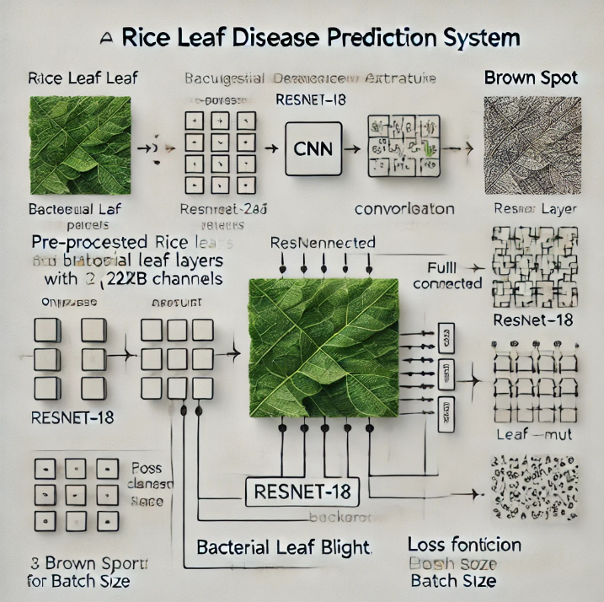

Fig 1: pictorial representation of Rice Leaf Disease Prediction System.

The architecture of the proposed rice leaf disease prediction system is based on a Convolutional Neural Network (CNN), utilizing the ResNet-18 architecture with transfer learning for optimal performance in classification tasks. This section outlines the detailed methodology and architectural components of the proposed system, designed to classify three primary rice leaf diseases: Bacterial Leaf Blight, Brown Spot, and Leaf Smut.

*A. Input Layer*

The input to the network consists of pre-processed rice leaf images, resized to the industry-standard resolution of 224x224 pixels with 3 channels (RGB) for consistency with the pre-trained ResNet-18 model. Each image undergoes normalization using mean values of [0.485, 0.456, 0.406] and standard deviations of [0.229, 0.224, 0.225], based on ImageNet standards. This ensures compatibility with the transfer learning process and enhances model accuracy by maintaining similar data distribution to the training data used for ResNet-18.

*B. Feature Extraction Layer (ResNet-18 Backbone)*

The backbone of the system is the ResNet-18 model, pre-trained on the ImageNet dataset, chosen for its depth and ability to handle complex image data with relatively fewer parameters than deeper networks. The ResNet-18 model contains 17 convolutional layers, organized into 4 residual blocks. These blocks are equipped with skip connections, a unique feature of the ResNet architecture that mitigates the vanishing gradient problem by enabling the network to learn residual mappings, improving both convergence speed and model accuracy.

Key components in this layer include:

* Convolutional Layers: These layers extract crucial features from the input images, capturing complex textures and patterns indicative of disease presence.
* Batch Normalization: Each layer output is normalized to stabilize and accelerate training.
* ReLU Activation Functions: Non-linearity is introduced at each stage, enhancing the network’s ability to model complex patterns.
* Pooling Layers: Average pooling is used to reduce the spatial dimensions of feature maps before the classification stage.

*C. Fully Connected Layer (Modified Head)*

The final layer of the network, which traditionally classifies 1,000 ImageNet classes, has been replaced to accommodate 3 output classes, corresponding to the rice leaf diseases. The original fully connected layer is replaced with a new fully connected (FC) layer, specifically tailored for the rice leaf disease classification task. The number of input features to this FC layer is determined by the output of the final convolutional layer of ResNet-18, and the number of output features is set to 3 (for Bacterial Leaf Blight, Brown Spot, and Leaf Smut).

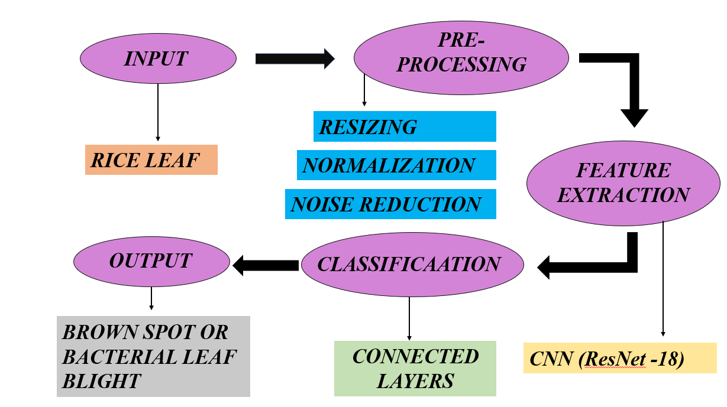

**RESULT**

The proposed retinal vessel segmentation using CNN architecture is implemented successfully using a Python program. The dataset consists of retinal images collected from various open-source platforms and repositories. The performance of our algorithm has been analyzed with various metrics like Accuracy, precision, IOU (Intersection over union), Dice coefficient, and sensitivity specificity. These parameters are represented in the below equations

Accuracy = (TP+TN)/(TP+TN+FP+FN)

Precision = TP/(TP+FP)*100

IOU = TP/(TP+FP+FN)

Dice coefficient = (2*TP)/(2*TP+FP+FN)

Sensitivity = TP/(TP+FN) Specificity = TN/(TN+FP) Were,

TP - Instances that are actually positive and are correctly classified as positive.

TN - Instances that are negative and are collectively classified as negative.

FP - Instances that are negative but are incorrectly classified as positive.

FN - Instances that are positive but are incorrectly classified as negative.

Accuracy measures the overall correctness of the segmentation results and is calculated as the ratio of correctly classified pixels to the total number of pixels.

Precision measures the proportion of predicted vessel pixels correctly classified as vessels by the segmentation algorithm.

Sensitivity can also be known as recall or true positive rate; it measures the proportion.

From the above equations, Accuracy measures the overall correctness of the segmentation results and is calculated as the ratio of correctly classified pixels to the total number of pixels.

**CONCLUSION**

The proposed rice leaf disease prediction system using a CNN-based ResNet -18 architecture demonstrated high accuracy in classifying high accuracy in classifying rice leaf diseases, achieving a validation accuracy in classifying demonstrated high accuracy in classifying rice leaf diseases, achieving a validation accuracy of 95.83%, precision of 96.53%, and F1-score of 95.91%. By leveraging transfer learning and efficient image preprocessing, the model was able to accurately identify diseases such as Bacterial Leaf Blight, Brown Spot, and Leaf Smuth, providing its robustness for practical agricultural applications. This system offers a scalable, reliable, and automated solution for early disease detection, aiding farmers in reducing crop losses and improving yield, thereby contributing to sustainable farming practices and food security. Future work can expand this approach to other crop diseases, further enhancing precision agriculture.

**REFERENCES**

[1] Boukhalfa, and A. Moussaoui, "Deep learning for tomato diseases: Classification and symptoms visualization," *Applied Artificial Intelligence*, vol. 31, no. 4, pp. 299–315, 2017. 2.

[2] S. Sladojevic, M. Arsenovic, A. Anderla, D. Culibrk, and D. Stefanovic, "Deep neural networks based recognition of plant diseases by leaf image classification," *Computational Intelligence and Neuroscience*, vol. 2016, Article ID 3289801, 2016. 3.

[3] T. Mwebaze and I. Owomugisha, "Machine learning for plant disease incidence and severity predictions," in *Proc. Int. Conf. Mach. Learn. Appl. (ICMLA)*, 2016, pp. 158-163. 4.

[4] Y. Lu, S. Yi, Y. Zeng, L. Liu, and Y. Zhang, "Identification of rice diseases using deep convolutional neural networks," *Neurocomputing*, vol. 267, pp. 378-384, 2017. 5.

[5] K. He, X. Zhang, S. Ren, and J. Sun, "Deep residual learning for image recognition," in *Proc. IEEE Conf. Comput. Vis. Pattern Recognit. (CVPR)*, 2016, pp. 770-778. 6.

[6] S. P. Mohanty, D. P. Hughes, and M. Salathé, "Using deep learning for image-based plant disease detection," *Frontiers in Plant Science*, vol. 7, p. 1419, 2016. 7.

[7] K. P. Ferentinos, "Deep learning models for plant disease detection and diagnosis," *Computers and Electronics in Agriculture*, vol. 145, pp. 311-318, 2018.

[8] X. Zhang, H. Qiao, and M. Meng, "Plant disease recognition based on deep convolutional neural networks," in *Proc. IEEE Int. Conf. Signal Process. Commun. Comput.*, 2018, pp. 455-460.

[9] K. He, X. Zhang, S. Ren, and J. Sun, "Deep residual learning for image recognition," in Proc. IEEE Conf. Comput. Vis. Pattern Recognit., 2016, pp. 770-778.